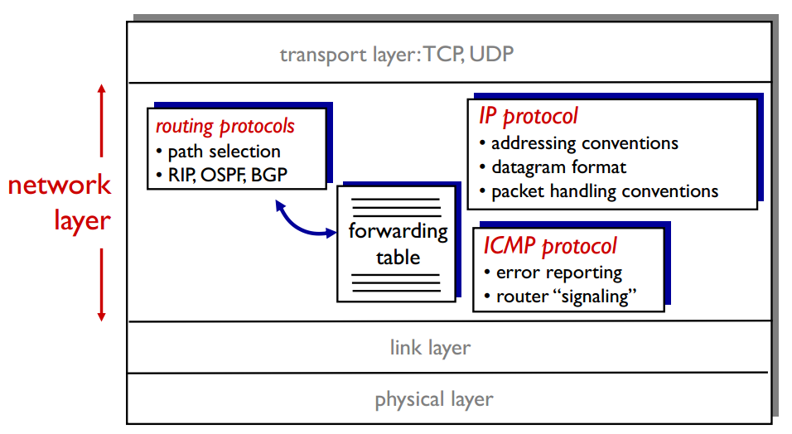

**IP fragmentation, reassembly IP的碎片化，重组**

network links have MTU (max.transfer size) - largest possible link-level frame

large IP datagram divided(“fragmented”) within net

one datagram becomes several datagrams

“reassembled” only at final destination

IP header bits used to identify, order related fragments

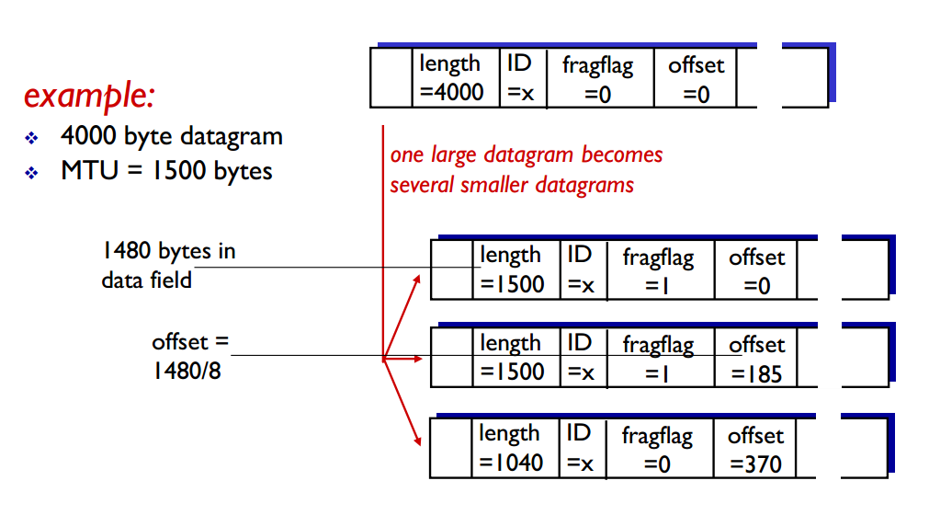

**IPv4 addressing**

IP address: 主机和路由器的32位接口标识符

interface：(网络接口卡)主机/路由器与物理链路的连接

wired Ethernet interfaces connected by Ethernet switches

wireless WiFi interfaces connected by WiFi base station

IP address:

subnet part: high order bits

host part: low order bits

what's a subnet ?:

device interfaces with same subnet part of IP address

can physically reach each other without intervening router

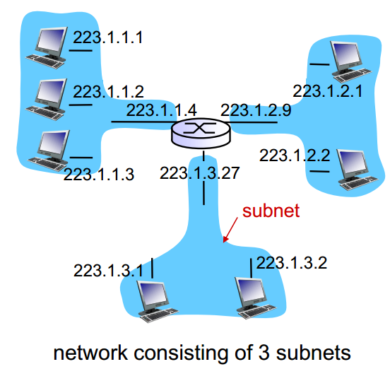

**IP addressing: CIDR**

Classless InterDomain Routing(CIDR):

任意长度地址的子网部分

address format: a.b.c.d/x, where x is # bits in subnet portion of address （x是子网部分的长度）

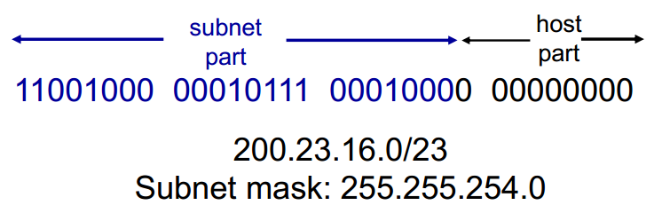

How to get IP address?

**DHCP**:Dynamic Host Configuration Protocol

dynamically get address from as server

**DHCP**

goal:允许主机在加入网络时自动获取一个IP地址

can renew its lease on address in use

allows reuse of addresses (only hold address while connected/“on”)

support for mobile users who want to join network (more shortly)

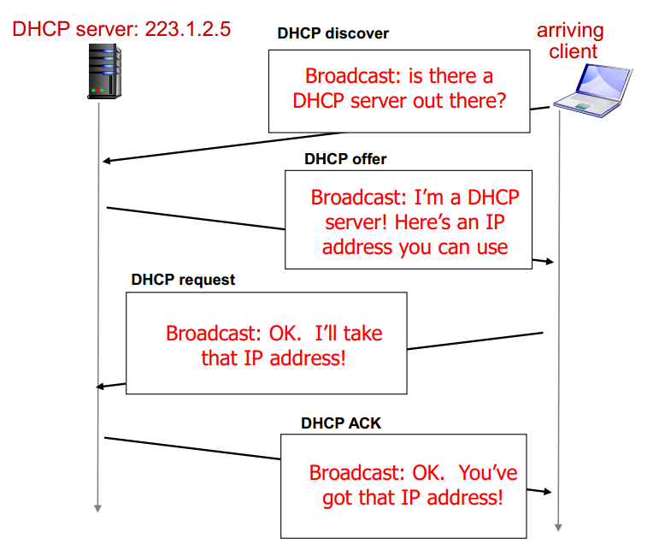

DHCP can return more than just allocated IP address on subnet：

address of first-hop router for client

name and IP address of DNS sever

network mask (indicating network versus host portion of address)

**how does an ISP get block of addresses?**

ICANN: Internet Corporation for Assigned Names and Numbers

allocates addresses

manages DNS

assigns domain names, resolves disputes

**network address translation**

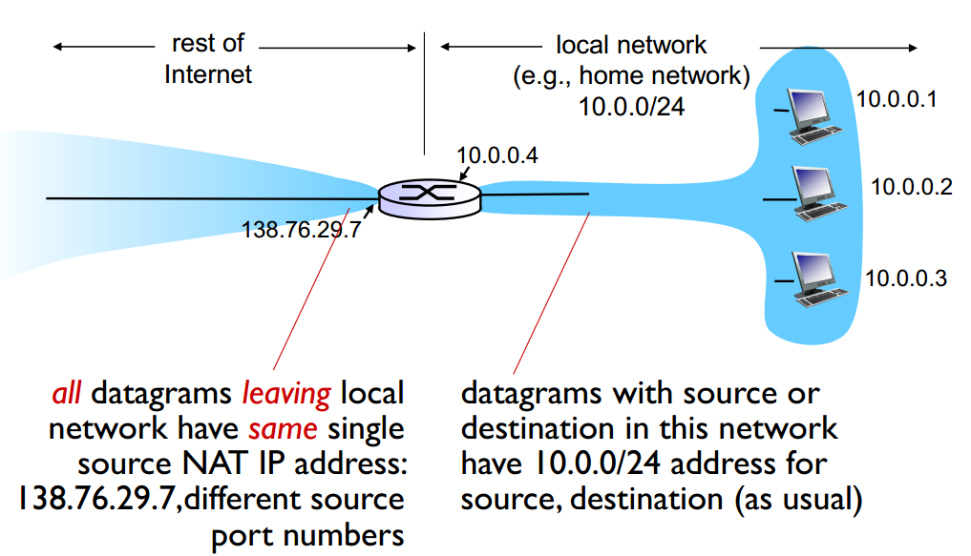

NAT使得路由器对外部世界来说甚至不像一台路由器。NAT路由器对外界的行为就如同一个具有单一IP地址的单一设备。

**IPv6**

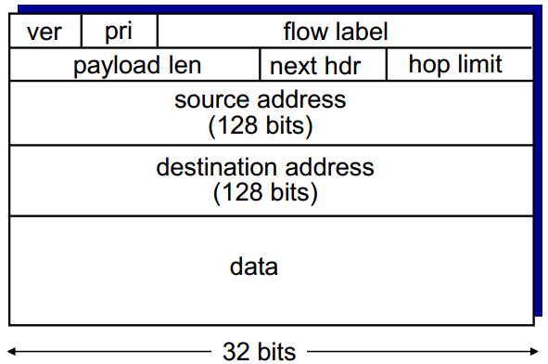

priority: identify priority among datagrams in flow

flow Label: identify datagrams in same “flow.”

next header: identify upper layer protocol for data

取消了checksum

options：还在，但是不在IP首部中了，出现在“Next Header”指出的位置上

**Transition from IPv4 to IPv6**

**tunneling**: IPv6 datagram carried as payload in IPv4 datagram among IPv4 routers

